PRACTICAL QUESTIONS FOR DATA VISUALISATION AND ANALYTICS (CIA1C11)
Practical 2 – Exploratory Data Analysis I (Data Profiling)

Introduction: Given a set of raw data, what is the process that one might go through to make sense of the data? Exploratory Data Analysis is about getting to know the data, discovering the problem areas and assessing what needs to be done to improve the data quality. Generally, these are the things that a data analyst will have to go through:
- Data Profiling – to get an overview structure of the data and assess the data quality
- Data Discovery – to use statistics charts to get a sense of the distribution / correlation

Practical 2-4 will introduce students to the application of such Exploratory Data Analysis.

Objective: The aim of Practical 2 is to focus on the EDA techniques for Profiling data using summary statistics and cross-tabulation.

Question 1 : To get familiarized with KNIME workspace
Question 2 : To read in data and explore the metadata (a summary of the basic info about the data)
Question 3 : To get a sense of the data via profiling (statistics node)
Question 4 : To explore the cross-tabulation between two numeric variables (crosstab node)

Dataset: For our task this week, we will make use of a dataset containing video game sales data for various genres of video games on different gaming platforms. For more details, you can visit this link (https://www.kaggle.com/gregorut/videogamesales)

Ready? Let’s get started!

Question 1 (Creating KNIME Workspace)
The purpose of this question is to get students familiarized with the KNIME workspace.
- Launch KNIME. You will be prompted to create/select a folder for your workspace.
You can click on the Browse button to bring up the explorer view to choose a folder to set as your workspace. There’s also an option to create a new folder.

You can check on the checkbox for Use this as the default and do not ask again option.
In this instance, we will use C:\KNIME as our workspace. Feel free to use a folder of your own choice, this will be the workspace for all our Practical for this subject.
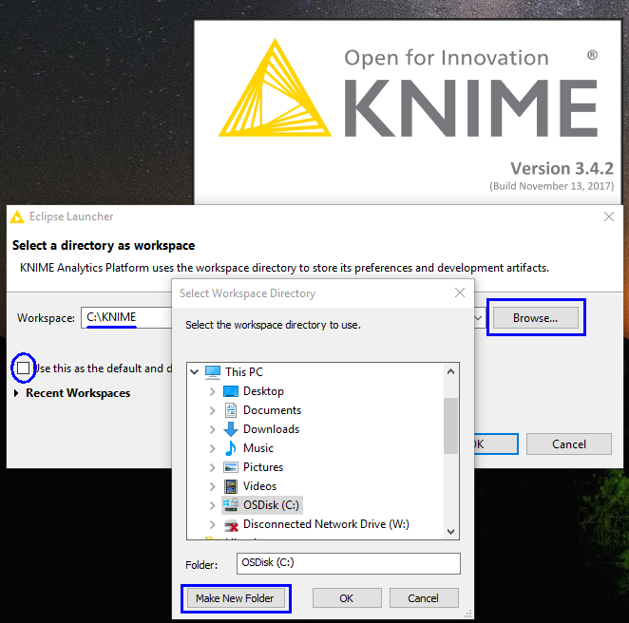
- The KNIME workspace is divided into several panels.
The top left corner shows your various KNIME workflows and workflow groups (more on that later). The bottom left corner contains all the nodes found in KNIME.
The top right corner shows the description of the selected node, right now, we do not have any nodes selected, hence it is empty.
The center is the main canvas where we will add nodes later on.
You can choose to show / hide any of the panels, but we will leave it as the default view for now.
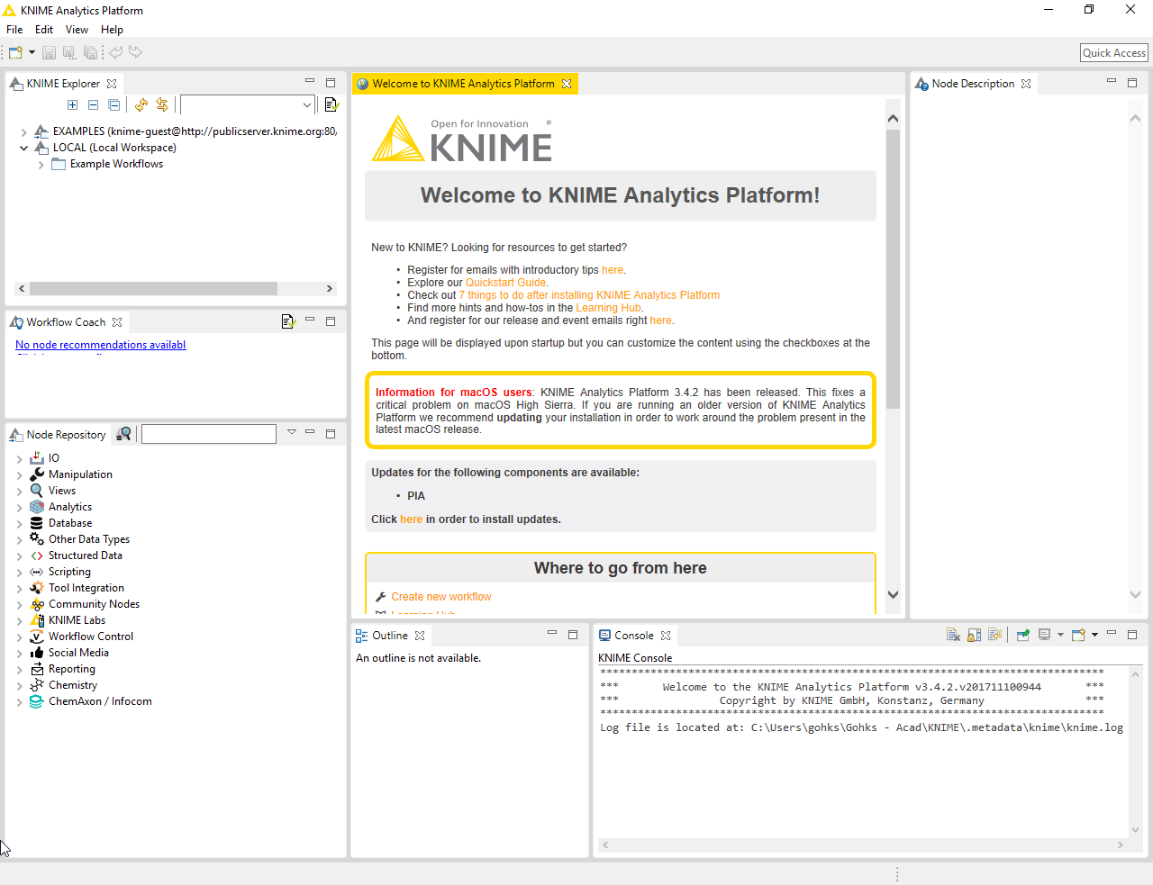
If at any point, you wish to restore the default view, click on View > Reset Perspective
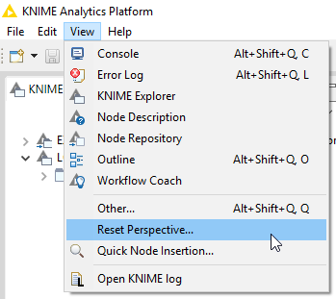
- We will proceed to create a new Workflow Group now. You can think of Workflow Groups as folders for you to organize your Workflows.

Click File > New
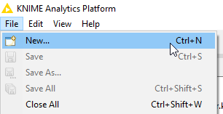
Double click New KNIME Workflow Group.
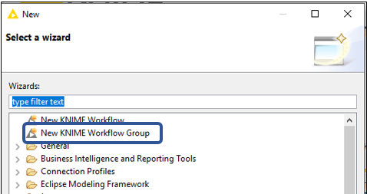
We will call this Workflow Group DAVA_Practical.
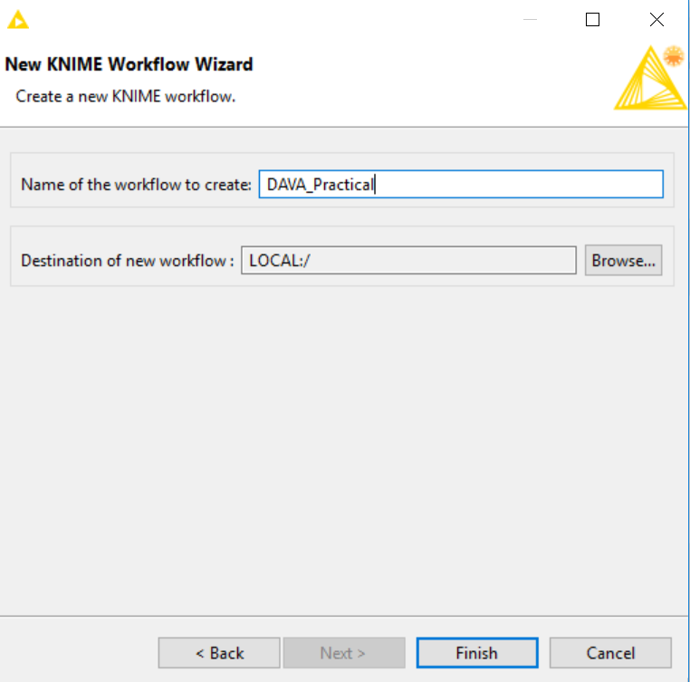
Click Finish.

You should be able to see this new Workflow Group at the KNIME Explorer panel (top left hand panel)
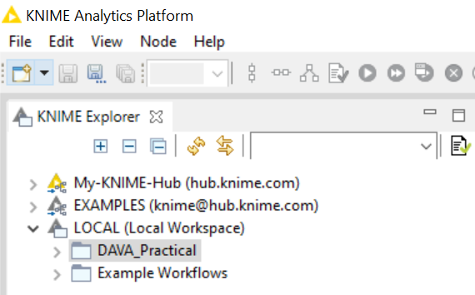

All our Workflows will go into this Workflow Group.
- We will now create a Workflow in the Workflow Group.
Ensure that you select the newly created Workflow Group in the KNIME Explorer.

Click on File > New
Select New KNIME Workflow
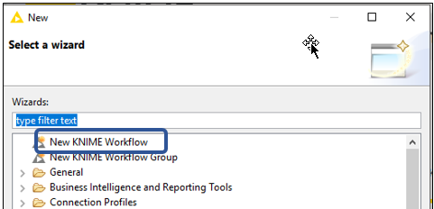
We will name this Workflow P02_Q1
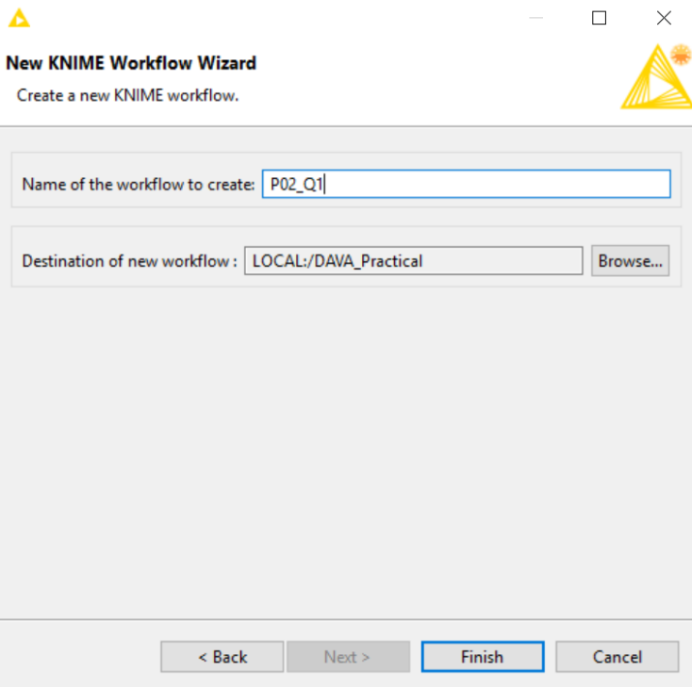
Click Finish

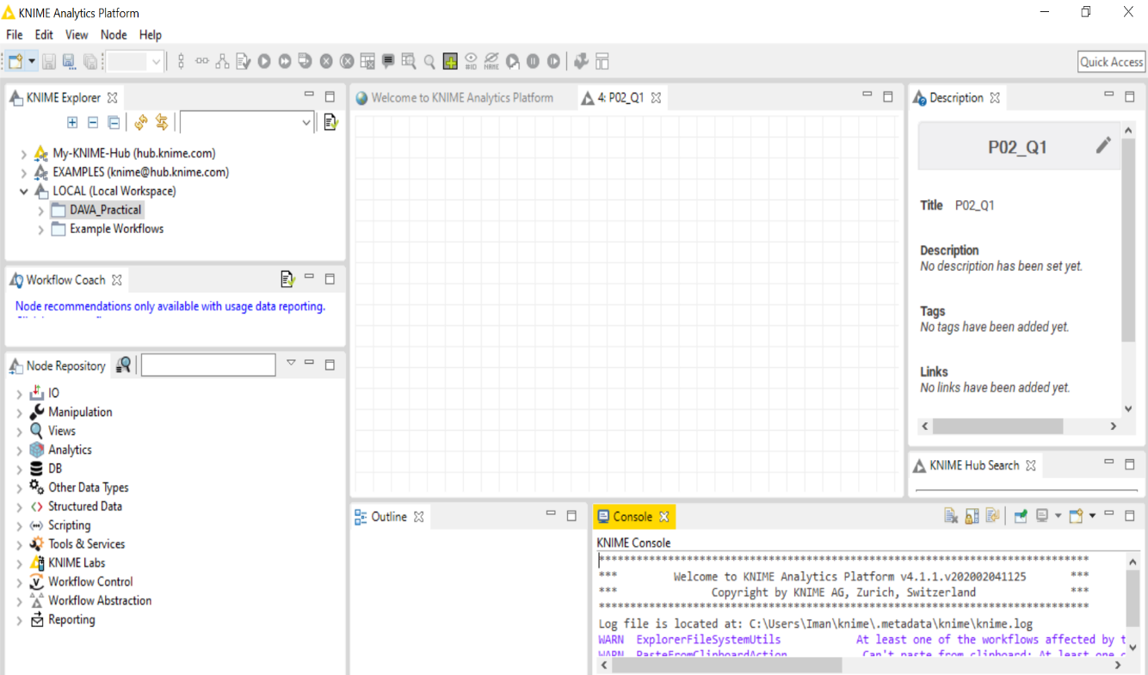
You should see the newly created Workflow in the center canvas.

Question 2 (Reading CSV files, basic file information)
The purpose of this question is to get a sense of what the data is like (using metadata).
The questions to consider are:
- How long and wide is the data?
- What is the range of value for each column?
- What is the data type for each column?

- We are now ready to add nodes to our first Workflow.

In the Node Repository panel (bottom left), enter “read” into the search box and press Enter.
[Note: The magnifying glass icon toggles fuzzy search option]

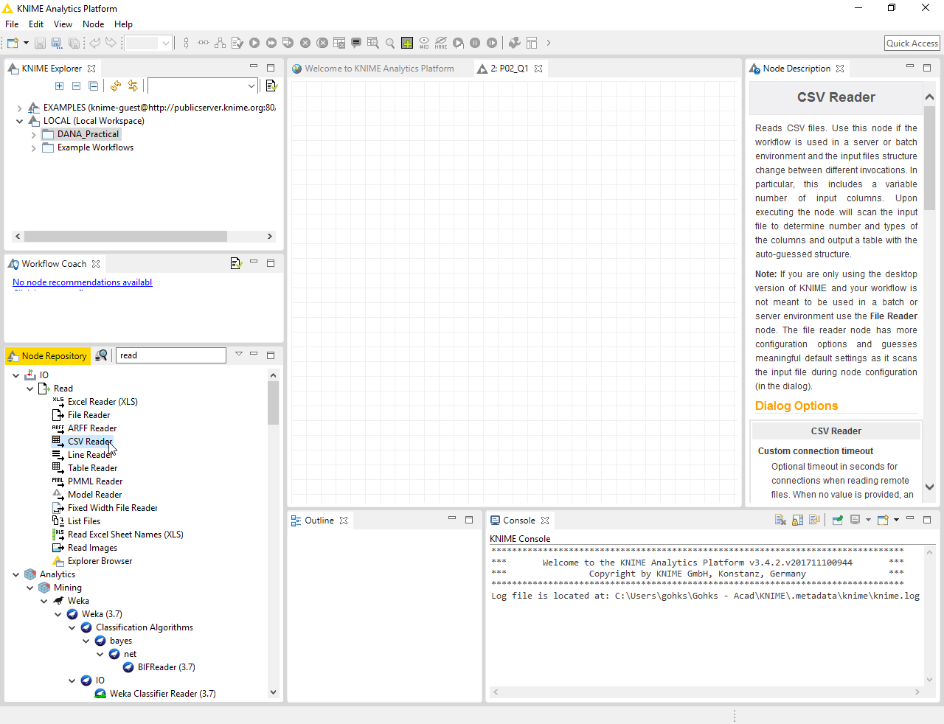
Select the CSV Reader node. As you click on the node, you should notice that the Node Description panel (top right) being populated with details of your selected node. This is where you can find out more about the various configuration options of your selected node.

You can either drag and drop this node onto the workflow or double click on it.
Go ahead and add the node to your workflow.
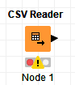
You would have noticed the traffic light (red, yellow, green) below the node.
In KNIME all nodes would have this traffic light status below it.
- Green - successful execution,
- Yellow - ready but not executed,
- Red - not ready or unsuccessful execution

Our node’s status is Red because we have not configured it.
- Let’s configure our node.
Right click on the node and select Configure.
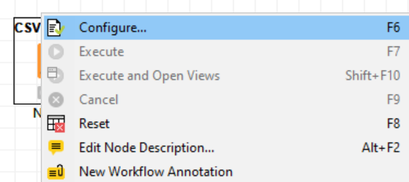

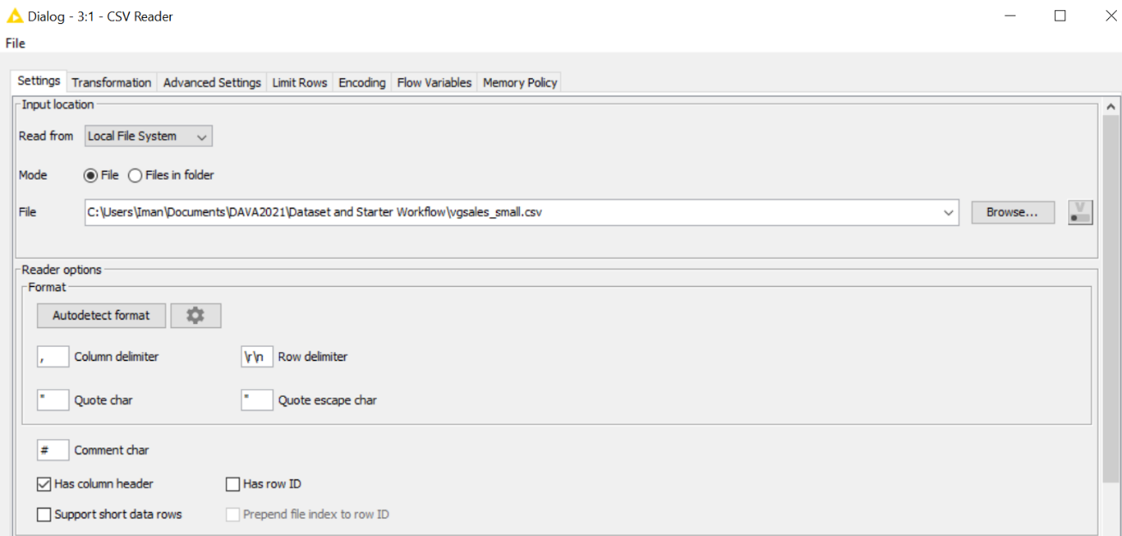
Click on the Browse button and navigate to the location of the file vgsales_small.csv

At the Settings tab, you can configure the column and row delimiters, as well as the character used to represent quotes and comments.

The two check boxes below the delimiters allow you to state whether your data file has column and/or row headers. The left-most column will be assumed to contain the row ids.

Since our data does not have row id, KNIME has automatically unchecked the Has Row ID option and let KNIME add it in for us.

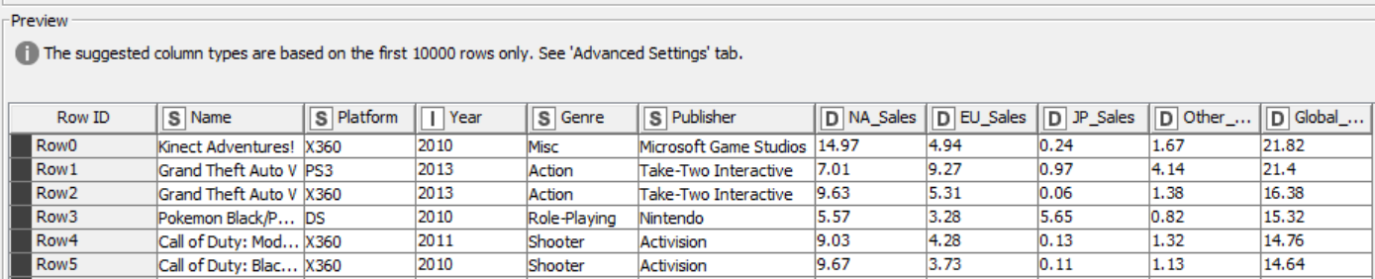
Scroll down and you will see a preview of the dataset.

Notice a warning “The suggested column types are based on the first 10000 rows only. See ‘Ádvanced Settings’ tab.”
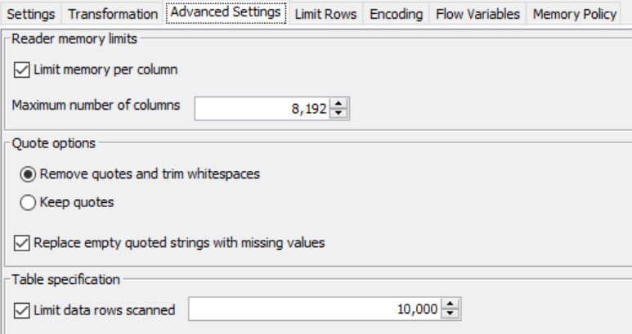

KNIME will read data in each column and ‘guess’ its type (double, string etc.). By default, it will read data from 10000 rows to do this ‘guessing’ but you can configure the number of rows if you wish to.

Navigate to the Limit Rows tab.
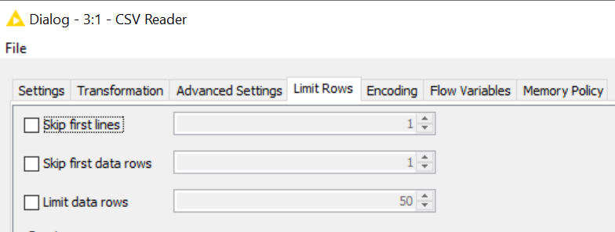

This tab allows you to skip lines in your input file if necessary.

No changes are required for now.

You can click on Ok to exit the configuration window.

- We are ready to run the node.
Right click on the node and select Execute

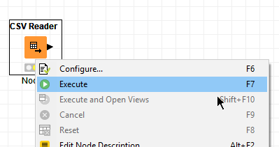

If everything is set correctly, the execution will succeed. The traffic light indicator will turn Green.

- Let’s view the results!
Right click on the node and select File Table
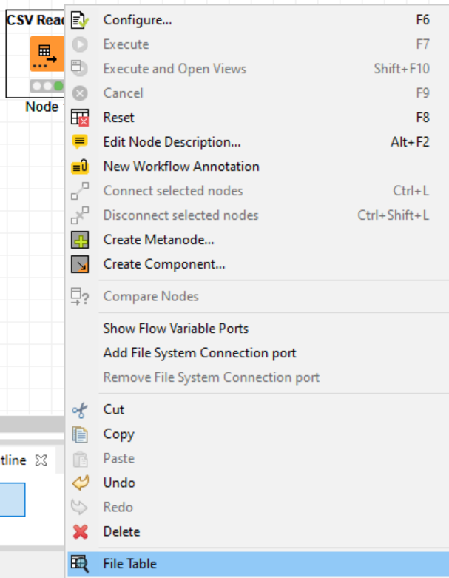

The imported data table will be displayed.
We can see the number of rows loaded in the summary.
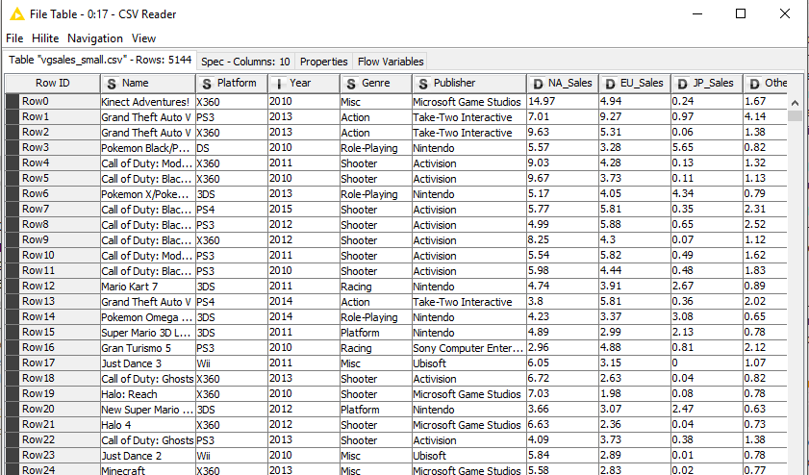
Noticed, also, that our load configuration caused the left-most column (Row ID) to be added.

You can click on any of the column to enable the sorting function.
By default, rows are sorted based on the order in the source file.

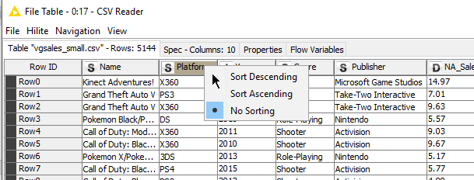

Click on the Spec – Columns tab.

In this view, you can see the that we have 10 columns, columns are indexed from 0 onwards.
KNIME has guessed the Sales columns to be Number (double) type, and the Platform, Genre and Publisher to be of String type.

For the numeric fields, the upper and lower bound are summarized.
For categorical fields, all possible values are shown in Value 0 to Value n (n = number of possible values)

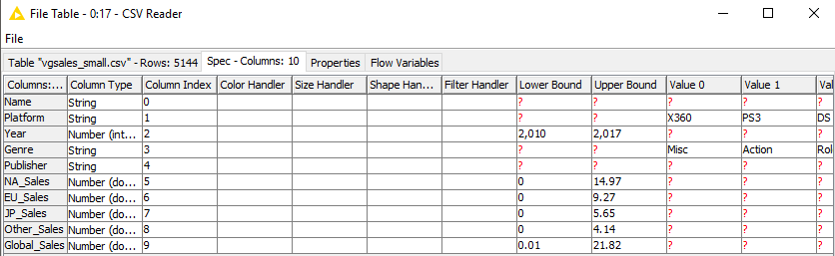

You can proceed to close the table for the CSV Reader.

You can save this workflow by going to File > Save.

Note that it is named as P02_Q1 even though this is Question 2, but that’s ok.

Question 3 (Using the File Reader and Statistics node)
The purpose of this question is to get to know the data using summary statistics.
The questions to consider are:
- What is the min, max, mean, median, standard deviation of each column of data?
- What is the spread/distribution of the data for each column?
- How many missing values are there in each column?

In the process of exploring the data, we may be able to discover things such as:

- Which region has the best video game sales performance?
- Which genre of games has the most titles?
- Which publisher has the most titles?

- Create a new Workflow called P02_Q3 using File > New > New KNIME Workflow

- File Reader
We will load the Video Game Sales dataset in using a different method.

Add a File Reader node to your workflow. Select the vgsales_small.csv file.

The File Reader node is one of the most versatile node for importing data into KNIME.

Notice that the settings is slightly different from the CSV Reader, one of the key difference is the availability of the preview at the Settings tab.

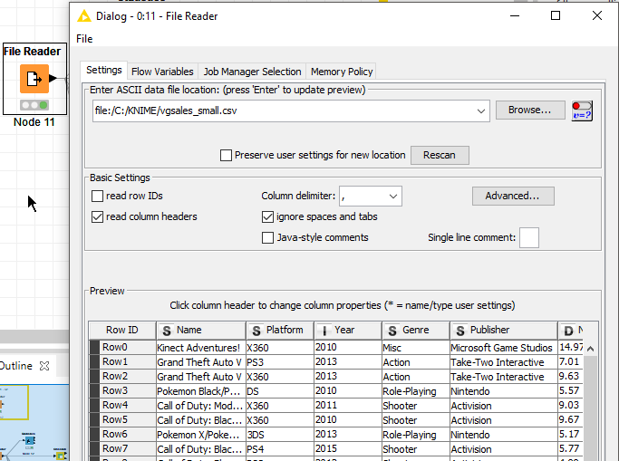

Ensure that the read row IDs check box is unchecked.
Execute the File Reader node.

- Statistics - Numeric
Add a Statistics node downstream from the File Reader node.
Double click on it to access the configuration screen.
[This is a short cut to Right-Click > Configure]

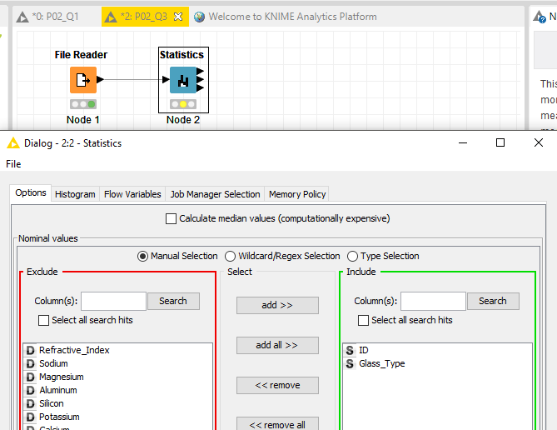

We want to select all the numeric fields, you can do it manually, but a faster way of achieving this is to go to the Type Selection option and check the checkboxes for Number (double) and Number (integer) this will select the 6 numeric fields in our dataset.

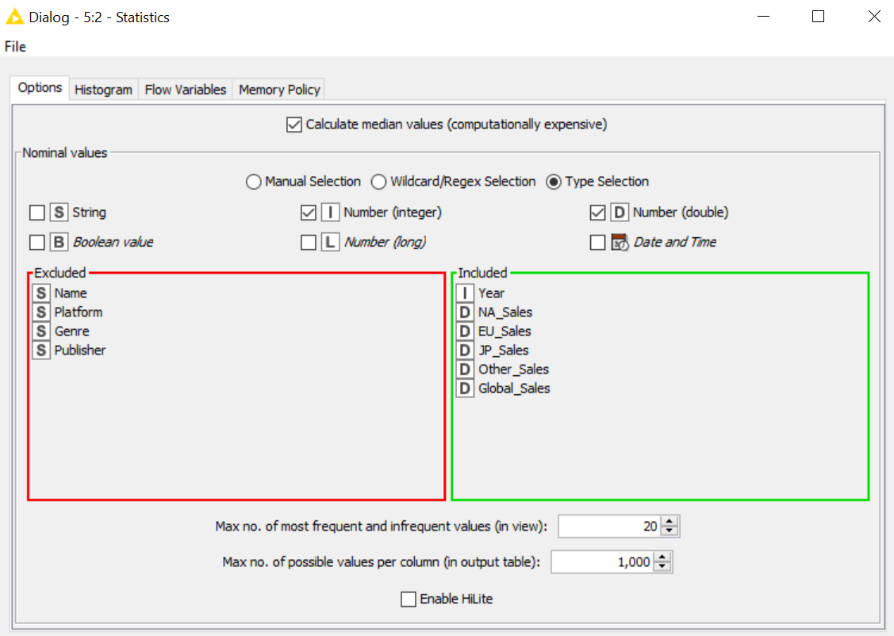
Check the check box for Calculate median values. By default, this is unchecked in the statistics node since computing median can be a computationally expensive operation.

 | Discussion: Why do you think computing Median is a computationally expensive operation?
Answer:

In order to calculate the median, the data must first be ranked (sorted in ascending order).
The median is the point at which exactly half of the data are above and half below.

Right-click on the Statistics node, select Execute and Open Views

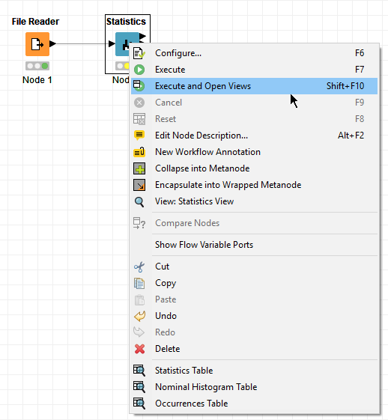

The result consists of 3 tabs. Let us first look at the Numeric Tab.

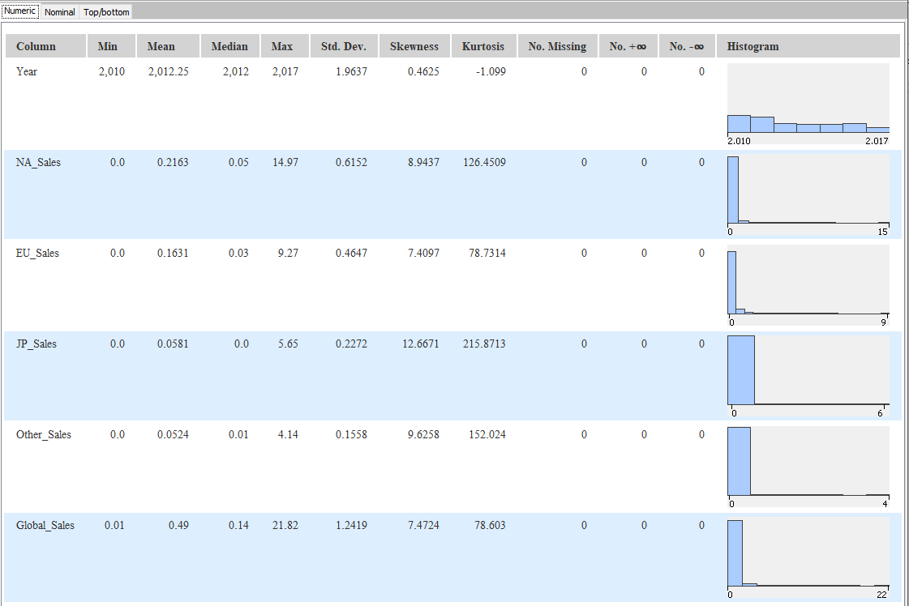

The Statistics node computes the summary statistics (min, max, median, mean, standard deviation etc.) of each of the numeric field and also produces the histogram to show the spread of the values for the field. There’s also a column showing you the number of missing values for each field, a useful feature! (Note : NaN means not a number)

It is possible for some upstream nodes to produce ‘infinite’ values, if you were to connect the statistic node downstream, the last 2 columns would be useful for showing you the number of ‘infinite’ values produced.

 | Question:  - Which region has the best video game sales performance?
Answer:

Close the Views window.
You can always bring up the Views window later on by right clicking on the node and selecting the View: Statistics View option.
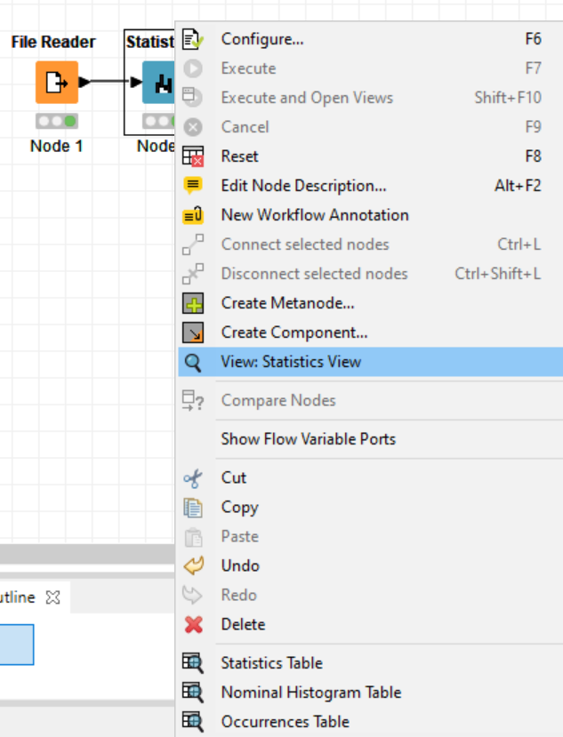

- Statistics – Nominal
Select the option to configure the Statistics node again. This time, we will run the node for non-numeric fields. In the Manual Selection view, add the Platform, Genre and Publisher into the Include group. Uncheck the checkbox to Calculate median values (since we are dealing with non-numeric fields), click the radio button to enforce exclusion for the remaining fields and click Ok.

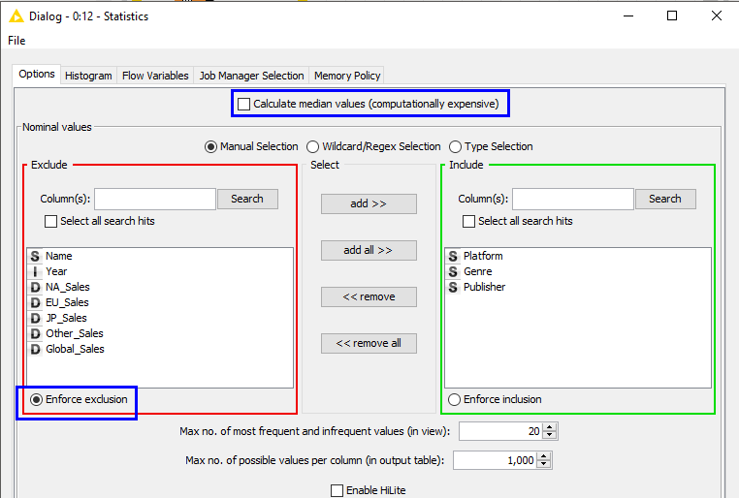

You will get a warning message informing you that the change in settings for the node is detected and that basically, the changes will affect any connected nodes downstream as well as previously stored results. At this point, you can click Cancel to discard the changes in the settings, or you can click Ok to proceed with the changes.

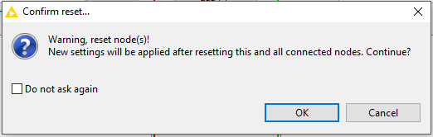

Since the changes is intended, click Ok.

Notice that the traffic light indicator for the Statistic node is changed to Yellow once the settings is changed. Recall that Yellow represents “ready but not executed”. This is correct since we have not run the Statistics node with the updated changes.

- Run the Statistics node by right clicking on the node and selecting Execute and Open Views. The changes we have made (adding in the 3 nominal fields) will be apparent in the second and third tabs in the results.

Click on the Nominal tab. We can see a summary of the nominal fields, in this case, there are no missing rows for the fields (missing = 0). We can also see a Histogram for the distribution of the field. Note that the term ‘histogram’ is a misnomer for the visualization here, since histograms should be used for numeric fields.

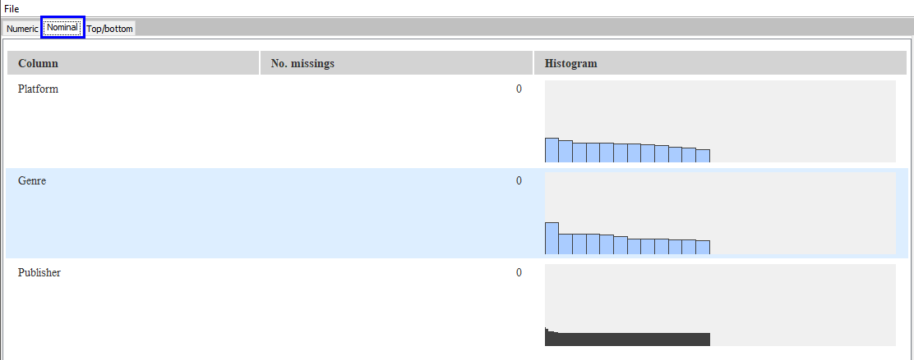

You can mouse-over any of the bars that you’re interested in to see details of the distribution. In this case, we are looking at the Genre field. We can see that there are 1440 video games with Genre = Action.

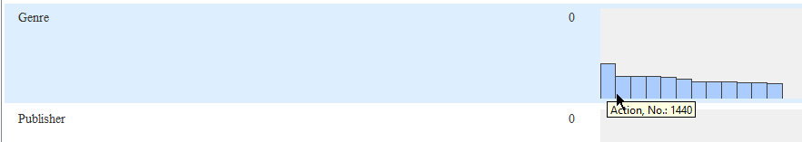

 | Question:  - Which genre of games has the most titles?
Answer:

 | Discussion: What should be the correct term used to describe the visualization for nominal fields?
Answer:

Bar charts. With bar charts, each column represents a group defined by a categorical variable; and with histograms, each column represents a group defined by a quantitative variable. Bar charts typically have gaps between the bars to indicate the separateness of each value.

Navigate to the Top/bottom tab. This shows you the top 20 and bottom 20 values (based on count) for the field. Since our data set contains fewer than 20 Platform and Genre, this tab is not particularly useful for the two fields. However, it is useful for the Publisher field, we can see which are the top 20 and bottom 20 publishers in terms of game sales. Noticed that the frequencies are displayed next to the values.

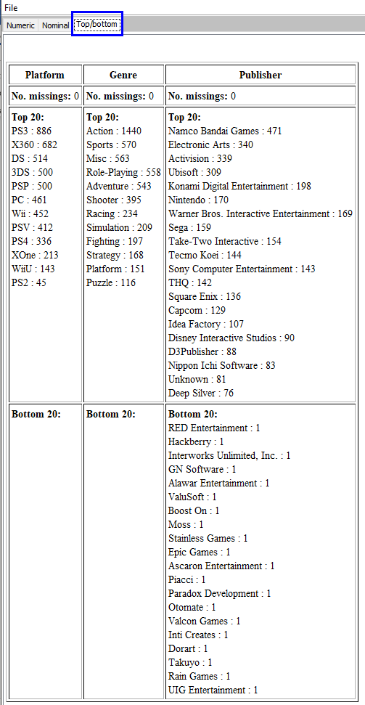

 | Question:  - Which publisher has the most titles?
Answer:

- Close the statistics view and save your workflow.

 | Reflection:  What can I find out using the Statistics node?
Answer:

Numeric Variables

Nominal Variables

Question 4 (Crosstab node)
The purpose of this question is to explore the distribution between two categorical variables. The questions to consider are:
- When variables are cross-tabulated, are there any interesting distribution / trends?

In the process of exploring the data, we may be able to discover things such as:
- How many games were released over years for each genre?
We will continue this question in the P02_Q3 workflow.
- Crosstab
Search for the Crosstab node and connect it downstream from the File Reader node.

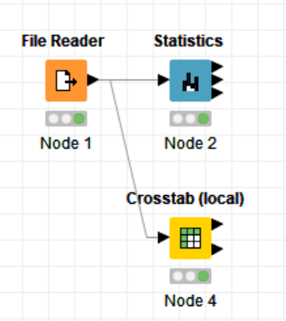

Configure the Crosstab node as follows:
Row variable = Genre
Column variable = Year
Weight column = None

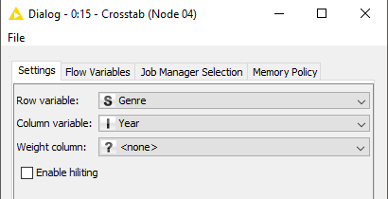
Make sure this is none if you want to display the frequency

Click Ok, then right-click on the node and select Execute and Open Views

By default, the Crosstab node will display the frequency as well as percentages. You can modify the view by checking / unchecking the checkboxes found at the top right corner of the view.

Uncheck everything except Frequency.
Update the maximum number of rows to 12 so that all genres are visible.

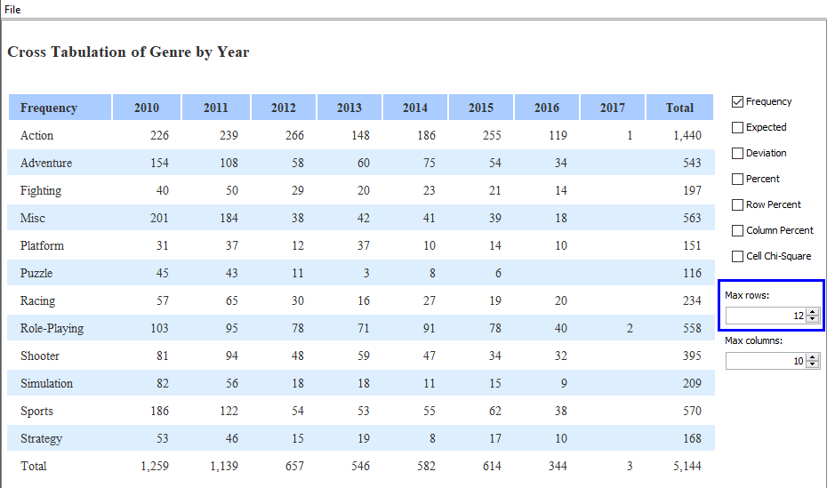

 | Question:  - How many games were released over years for each genre? (not including Misc = Miscellaneous)? Do you any special trend happening?
Answer:

- Save your workflow.

 | Reflection:  What is the purpose of Crosstab node?
Answer:

Question 5 (Practice Question – Will not be covered in class)
- Create a new workflow, call this P02_Q5. Read the Laptop Prices.csv dataset into KNIME.
How many columns and rows were read?

- Which field, apart from price_euros, has the largest standard deviation? Are there any missing values among the fields read?

- Which company produces the most gaming laptop? Which companies have the most comprehensive range of products?

– End of Practical 2 –
 | Summary:
In this practical, we explored the use of summary statistics to explore numeric data. Descriptive statistics such as the mean, median provides insights on the central tendency of numeric data while statistics like maximum, minimum and standard deviation provides insights on the spread of numeric data.

Cross-tabulation allows us to see the distribution of data points across two dimensions.

In this practical we made use of the following nodes in KNIME.
Node | Purpose | Remarks
CSV Reader | Read comma separated files | Will create extra column if data does not have ID column.
File Reader | Read files into KNIME | One of the more versatile file import nodes in KNIME. Can handle a large variety of files including CSV files.  Provides preview function and functionality to change data type.
Statistics | Produce descriptive statistics for imported fields. | Computation of median is disabled by default
Crosstab | Produces frequency table for selected fields. | If weight column is a selected field, the frequency will be adjusted based on the value of the field.

